Robert Beaty  Breathing Innovation into Healthcare: My Extraordinary Journey  I recently sat down with a VA colleague with an interesting story. Michael (Mike) Golub, RRT, RN is the VP of Critical Care Solution, Inc. and is also a respiratory therapist for the West Palm Beach VA Healthcare System. Mike shared with me his unique entry to the respiratory care world as well as his invention, the Simplified and Improved Nebulizer Oxygen Delivery Adaptor (SINODA).  Mike, you are from Ukraine but found your way to the United States; can you tell me about that?  [Mike] Picture a life that starts in Kiev, Ukraine, takes a detour through the Air Force (Ukraine), and arrives at the forefront of healthcare innovation in the USA. This is my story, and it's nothing short of extraordinary.  I hail from Kiev, where I earned my Engineering Degree at the Industrial College. After proudly serving my country in the Air Force, I embarked on a journey that would redefine the healthcare landscape.  You eventually immigrated to the United States and became both a Registered Respiratory Therapist and a Registered Nurse. You must have had quite the healthcare journey as well.  [Mike] For over two decades, I was on the frontlines, providing healthcare to patients of all ages - from Neonatal to Pediatric, Adult to Veteran populations. My path led me through the ER, Trauma ICU, Surgical ICU, Open Heart surgeries, Neonatal ICU, Pediatrics ICU, Medical ICU, Coronary Care ICU, and Long-Term Care Facilities. I've seen it all.  Yet, amidst these life-saving moments, I couldn't ignore the glaring issues with disposable respiratory care equipment. The struggles were real: improper placement, skin injuries, medication wastage, and patient discomfort. The existing solutions were far from ideal - complex, costly, and limiting.  So, this led you to invent SINODA?  [Mike] Not at first. Fueled by an unyielding desire for change, I embarked on a mission to revolutionize the game. I became the VP of Critical Care Solution, Inc., with a clear vision: to provide healthcare professionals with unique, cost-effective products that would elevate the quality of care to unparalleled heights.  This vision gave birth to MUNODA (Multi-functional Use Nebulizer Oxygen Delivery Adaptor), a device that etched its name in history with a US Patent (Patent No.: 10,441,739 B1). But I wasn't done yet. MUNODA evolved into SINODA (Simplified and Improved Nebulizer Oxygen Delivery Adaptor), a structural marvel. |  | 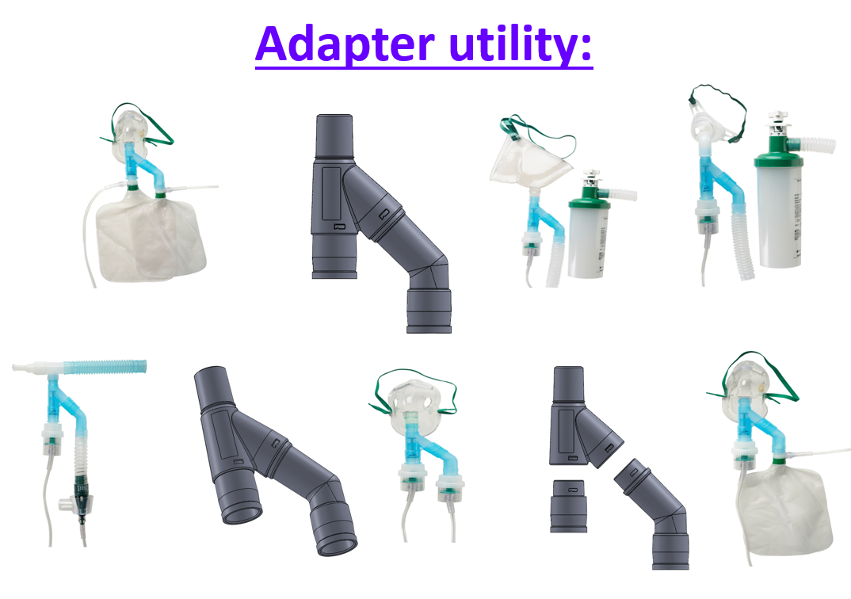
I was unfamiliar with MUNODA and its subsequent version SINODA prior to coming to this VA. MUNODA had some following, but SINODA really improved on the device. But you told me it’s not “just a device”, tell me more.
[Mike] SINODA is more than a device; it's a healthcare revolution. It's multi-functional, multi-configurational, MRI compatible, latex-free, and procedural. It's designed to seamlessly integrate with existing disposable respiratory care technology. It solves the perplexing problem of simultaneously delivering bronchodilator treatment and oxygen under odd angles, redefining patient care.
But SINODA isn't just a tool; it's a canvas for healthcare professionals to unleash their creativity. It empowers them to innovate, save time, and enhance patient satisfaction. From Non-Rebreather Masks to Venturi Devices, SINODA adapts to all, ensuring efficient medication delivery, particle deposition, and minimal waste.
This pocket-sized superhero doesn't stop there. It mixes different medical gases, delivering them at varying rates and concentrations - from Air to Oxygen, Nitric Oxide, and Helium Mixtures. With SINODA, healthcare professionals become artists, creating the perfect treatment cocktail for their patients.
SINODA is cost-effective, user-friendly, and embraces an "open system concept" with minimal moving parts. It's a game-changer at the bedside, especially for patients in challenging positions, like those with Tracheostomies. It eliminates the need for cutting into corrugated tubing and spring-loaded valves, streamlining treatment and saving therapists’ precious time.
You are always so passionate when you speak of SINODA. Why do you think Respiratory Care Departments should carry this product?
[Mike] In a world grappling with rising respiratory problems, SINODA is the answer respiratory therapists have been waiting for. It empowers them to offer double nebulization when needed and creative solutions to meet patients' unique demands.
Not only does SINODA simplify care, but it also saves money. Its versatility, uniqueness, and ability to perform multiple tasks reduce the need for multiple pieces of equipment, making it a cost-effective investment for healthcare facilities.
Critical Care Solution, Inc. takes pride in manufacturing SINODA in the USA, with a team of top professionals dedicated to changing the face of healthcare.
So, SINODA is available to the VA?
[Mike] Yes, Critical Care Solution, Inc. takes pride in manufacturing SINODA in the USA, with a team of top professionals dedicated to changing the face of healthcare. It is available to the VA through its distributers.
What’s next for you Mike?
[Mike] My journey doesn't end here. I continue to push the boundaries of innovation, with new products and patent applications on the horizon.
Intrigued? My story is more than interesting; it's an inspiring testament to the power of innovation and dedication. Join me on this extraordinary journey of transforming healthcare, one breath at a time. If you are interested in SINODA or learning about future products, please email me at rtrnmg@yahoo.com.

